Write a program for BFS using python code

Aim :To implement the Breadth-First Search (BFS) algorithm using Python.
Procedure:
- Create a graph using an adjacency list.
- Start traversal from the source node.
- Visit the node and mark it as visited.
- Add its unvisited neighbors to the queue.
- Repeat until the queue is empty.

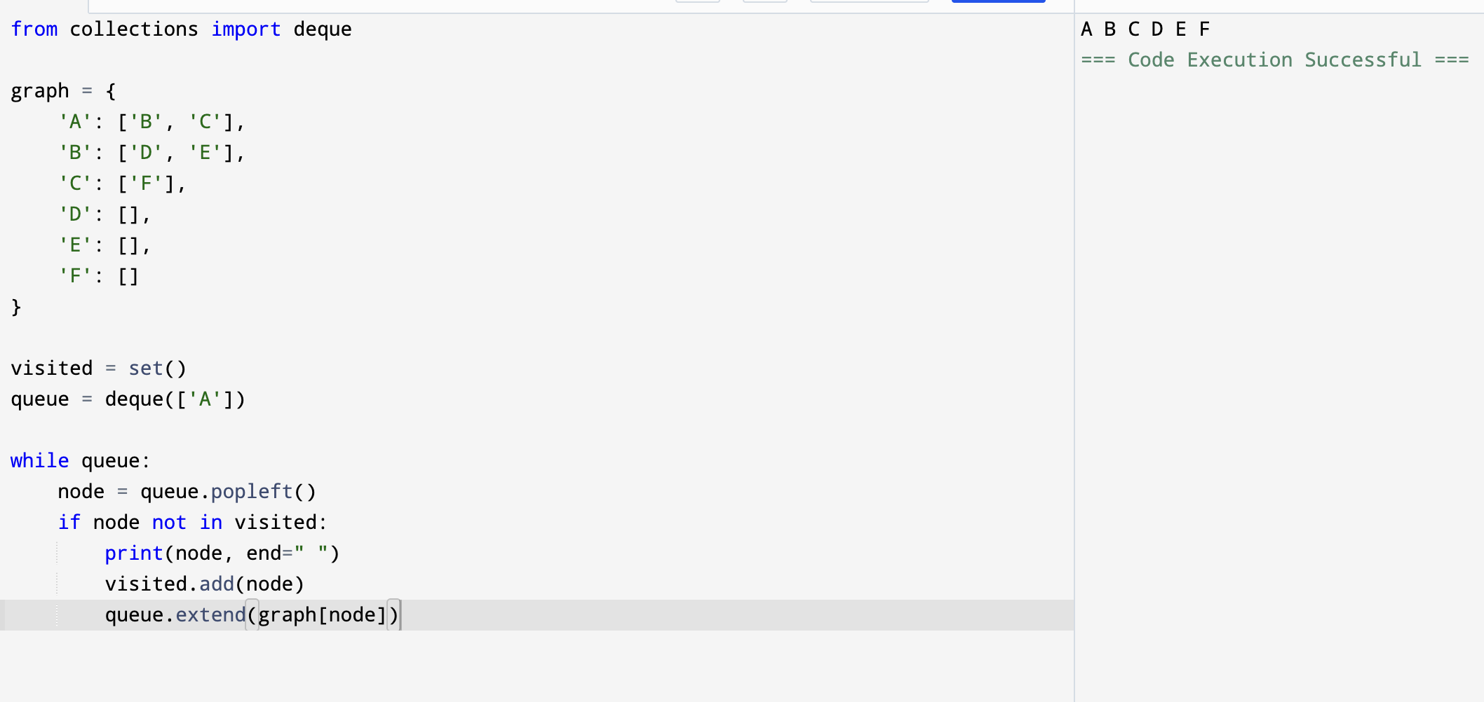
Output:

Result: Hence, BFS problem has solved

